FORMULAS-DE-DESVIACION-Y-MEDIAS.R

maria

2021-02-25

# Maria de Jesus Ramirez Navejar  
# Matricula: 1965814  
# Fecha: 25.02.2021  
  
dbh <- c(16.5, 25.3, 22.1, 17.2, 16.1, 8.1, 34.3, 5.4, 5.7, 11.2, 24.1, 14.5,  
 7.7, 15.6, 15.9, 10, 17.5, 20.5, 7.8, 27.3,9.7, 6.5, 23.4, 8.2, 28.5,  
 10.4, 11.5, 14.3, 17.2, 16.8 )  
length(dbh)

## [1] 30

# Medidas de tendencia central--------------------------------------------  
  
# Media  
  
mean(dbh)

## [1] 15.64333

sum(dbh)/length(dbh)

## [1] 15.64333

# Mediana   
  
median(dbh)

## [1] 15.75

# Media geometrica   
  
exp(mean(log(dbh)))

## [1] 13.93962

# Moda  
  
moda = function(x)  
{  
m1 <- sort(table(x), decreasing = TRUE)  
moda <- names(m1[m1== m1[1]])  
moda <- as.numeric(moda)  
return(moda)  
}  
  
# Medida de dispercion ---------------------------------------------------  
  
# rango  
range(dbh)

## [1] 5.4 34.3

# Varianca (s elevado a la 2 )  
  
var(dbh)

## [1] 55.48599

# Desviacion estandar (s) funcion sd   
  
sd(dbh)

## [1] 7.448892

# Obtener la rais cuadrada de la varianza me da la SD  
sqrt(var(dbh))

## [1] 7.448892

# cuantiles o percentiles  
  
quantile(dbh, 0.5) # El cuantil 0.5 correspondiente al valor de la media

## 50%   
## 15.75

# Cuantil 15%  
  
quantile(dbh, 0.15)

## 15%   
## 7.905

# Funcion fivenum  
  
fivenum(dbh)

## [1] 5.40 9.70 15.75 20.50 34.30

# Coeficiente de Variacion (CV %)  
  
100 * sd(dbh) / mean(dbh)

## [1] 47.61704

# Representacion grafica --------------------------------------------------  
  
  
# Grafica de Boxplot o de cajas   
  
boxplot(dbh, horizontal = TRUE, col= "red",  
 main = "Grafica de boxplot", xlab = "Diametro (cm")

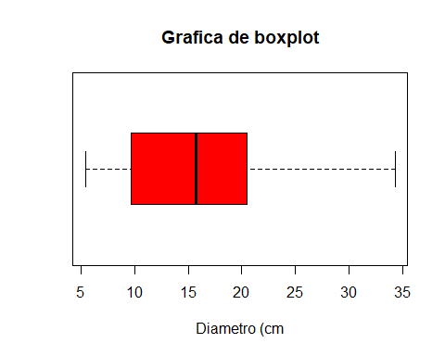

# Grafica de Tallo y Hoja (stem)  
  
stem(dbh, scale= 2)

##   
## The decimal point is at the |  
##   
## 4 | 47  
## 6 | 578  
## 8 | 127  
## 10 | 0425  
## 12 |   
## 14 | 3569  
## 16 | 158225  
## 18 |   
## 20 | 5  
## 22 | 14  
## 24 | 13  
## 26 | 3  
## 28 | 5  
## 30 |   
## 32 |   
## 34 | 3

# Grafica de histograma   
hist(dbh, main = "Histograma", xlab = "Diametro (cm)", ylab = "Frecuencia",   
 ylim = c(0,10), col="green", xlim = c(5,40))

